Introducing Cycling into National Energy and Climate Plans
European Cyclists’ Federation
James Armstrong | ECF, Policy Intern policy@ecf.com
05 December 2018
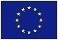 ECF gratefully acknowledges financial support from the European Commission. The information and views set out in this publication are those of the author(s) and do not necessarily reflect the official opinion of the European Union. Neither the European Union institutions and bodies nor any person acting on their behalf may be held responsible for the use which may be made of the information contained therein.

National Energy and Climate Plans

National and Energy and Climate Plans (NECPs) are the EU’s chief method to meet its climate change goals. Simply put, the EU and member states have agreed that all member states should, every 10 years, develop a 10 year plan setting out how they will meet their climate change commitments (2030 Climate and Energy Targets, and the Paris Agreement). The first national plans should cover the period from 2021 to 2030, including a perspective until 2050, to ensure long term consistency in policy objectives. The first drafts of which are due 31 December 2018, and must be confirmed by the commission by the same date a year later. It is clear to ECF that cycling could play a prominent role in member states plans, given the negative track record of the transport sector since 1990. The need to develop an NECP is therefore a potential route to more spending on pro-cycling projects by EU member states, as well as a push towards other national legislative initiatives promoting cycling interests and modal share.

We have seen repeated calls for the transport sector to make more of a contribution towards meeting GHG emissions targets, with both the Graz Declaration and the European Commission Long Term Climate Strategy seeing the transport sector as key to emissions reductions. This is unsurprising given the highly disappointing news that the GHG emissions transport sector have risen 7.44% since 2013, which is totally incompatible with global efforts to limit global warming to 1.5°C, or even to reach 2°C. National level data for the transport sector can be found here.

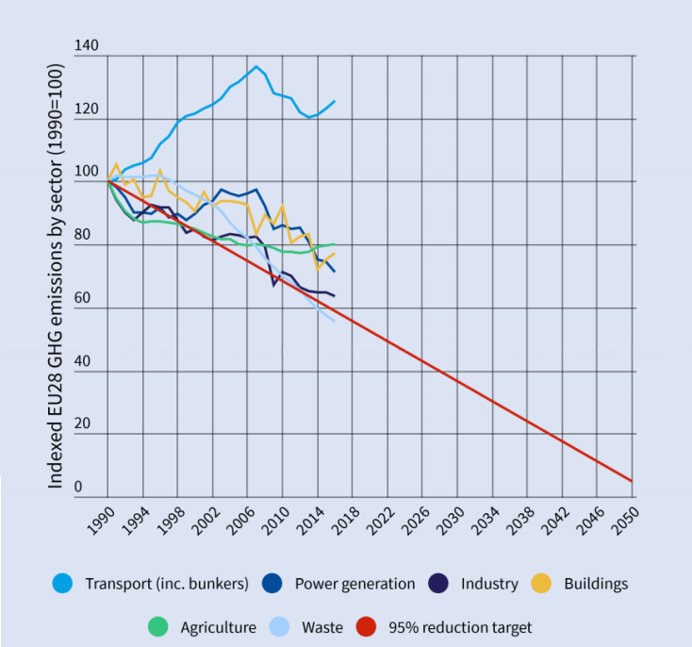

Data source: 1990- 2015 Member state Reporting to the UNFCC; 2016 EEA Approximated EU Greenhouse gas inventory.

Given all these factors, we think this is an excellent opportunity for you to put pressure on your national governments to act on cycling issues, as from December we have exactly one year to act. Particularly it is an opportunity to show policymakers the impact ambitious cycling modal shift targets could make to their obligations under NECPs. However the importance of the parts of the legislation that regard data reporting and predictions on emission levels should not be understated. If cycling is accurately represented in member states’ emission models, it will mean it will be easier in the future to make pro-cycling arguments to policymakers, as they will have their own data that supports what we are saying.

Timeline

The timeline of developing and implementing NECPs is as follows:

- By 31 December 2018: Member States prepare and submit to the Commission a draft of the NECP.
- By 30 June 2019: The Commission may issue recommendations on the draft plans.
- By 31 December 2019: Member States notify to the Commission their final NECP covering the 2021-2030 period, as well as a summary of the public’s views.
- By 15 March 2023: (+ every 2 years thereafter) Member States shall report to the Commission on the status of implementation of their NECP (Progress Report), including progress on reaching the targets, updates on policies and measures, and projections.
- By 30 June 2023: Member States submit a draft update of the NECP to the Commission or justify that the current plan remains valid.
- By 30 June 2024: Member States shall notify to the Commission a (final) update of the NECPs unless they have justified that the current plan remains valid.

Objectives
The NECP legislation contains six specific objectives of relevance to cycling, to be achieved by 2030:
- A 40% cut in economy wide greenhouse gas ("GHG") emissions;
- A 27% improvement in energy efficiency, with a view to a level of 30%;
- To update the Energy Union’s system for monitoring and reporting emissions and removals to reflect the Paris Agreement;
- To ensure the use of consistent data to report greenhouse gas emissions;
- To establish a regulatory framework for the Governance of the Energy Union with two main pillars: First, the streamlining and integration of existing planning, reporting and monitoring obligations. Second, the definition of a robust political process between Member States and the Commission;
- The proposed Regulation will contribute to the implementation of the Paris Agreement including its 5 years review cycle and ensures that monitoring, reporting and verification requirements under the UNFCCC and Paris Agreement are harmoniously integrated into the governance of the Energy Union.
How does cycling fit in?

The proposed regulation leaves the bulk of the decision making for how specific policy measures will be designed and implemented up to member states. It is therefore possible that cycling could fill a relatively significant part of the measures a member state choose to take, meaning that funding set aside to achieve their NECP could be used for cycling projects.

In the guidance document that was published to aid member states to develop their NECPs several areas highly relevant to cycling were mentioned/recommended. Member states are advised that their NECP contain:

1. Planned policies and measures to reduce greenhouse gas emissions, covering all key emitting sectors, including transport and agriculture, to meet the annual binding national limits for the non-ETS sectors up to 2030 set under the revised Effort Sharing Decision, with an outlook to the long-term vision and goal to become a low-carbon economy (2050);

2. National policies and measures planned to support the decarbonisation of transport;

3. National policy strategies and funding programmes for research and innovation in the areas of renewable energy, energy efficiency, and other low-carbon technologies including in the transport sector, as well as their market uptake, including strategies to support research and technology institutions.

Member state examples
Member states are not required to have submitted their final NECPs yet, however they have been in consultation regarding the plans with relevant stakeholders, European Institutions and other member states for some time now. Some states have even published drafts of their plans prior to submission to the European Commission, and can be seen as examples of what we expect to see from other member states in the future. Below is a selection of some examples of concrete actions relevant to cycling in Draft NECPs:

Finland - 30% of journeys to be made by 2030 by walking and cycling.
Sweden - Electric Vehicle Premium providing a 25% purchase subsidy for e-bikes and e-scooters of up to 350m per year for 2018-2020.
Austria - Aim to increase cycle modal share from 7% to 13% by 2025.
What do to:

For the next year, December 31st 2018 to December 31st 2019, we will have the chance to make an impact on NECPs. We suggest to take the following actions to make the most of this limited period.

- Communicate with other appropriate stakeholders in your country to try and work together to influence the NECP;

- Contact your national ministers in charge of energy and climate policies highlighting the need to include cycling in NECPs in order to decarbonise the transport sector;

- Take part in stakeholder meetings organised by national governments on their NECP.
Suggested policies to advocate for:

- The organisation of a National Cycle Investment Fund, equipped with annual investments of at least 10 Euros per person, with the purpose of co-funding local and regional cycle projects, such as cycle highway projects, bicycle parking at railways stations and other measures;

- Introduce or extend a national support scheme for the purchase of conventional and electric bicycles (L1e-A), the latter similar to schemes given to electric cars in a number of countries, and/or set up tax-free allowance schemes to support commuters who cycle to work;

- Frame national support and coordination of cycling in a systematic manner, by developing and implementing a national cycling strategy with clear modal shift objectives;

- The provision of national resources to help cities develop and implement ambitious Sustainable Urban Mobility and Sustainable Urban Logistics Plans;

- Adaptations to national building codes that introduce a minimum number of bicycle parking spaces and a maximum number of car parking spaces.

Relevant documents:

EU legislation requiring NECPs, Explanatory memorandum on the Governance of the Energy Union.

NECP guidance document for NECP implementation, Guidance to Member States on National Energy and Climate Plans as part of the Energy Union Governance.

2030 EU GHG emissions targets and framework, A policy framework for climate and energy in the period from 2020 to 2030.

2050 EU Long Term Climate Strategy, A Clean Planet for all A European strategic long-term vision for a prosperous, modern, competitive and climate neutral economy.

2015 Paris Agreement, The Paris Agreement.

